What Caused the Great Depression?
The Great Depression lasted from 1929 to 1939 and was the worst economic downturn in U.S. history.
Underlying Causes | Explanation
Overproduction and Underconsumption
Crisis in Farm Sector
Increasing American Debts
Uneven Distribution of Wealth
Stock Market Speculation

On October 29, 1929, known as “Black Tuesday”, the U.S. stock market crashed when stock prices started to slide and people rushed to sell their stock and get out of the market, driving prices down even further. The stock market crash triggered the Great Depression.

What were the effects of the Great Depression?
- Bank Failures:

- Business Failures:

- Unemployment:

- Poverty:

What was the Dust Bowl?
The Dust Bowl was the name given to southern Great Plains region of the United States (Colorado, Kansas, Texas, Oklahoma, and New Mexico), which suffered severe dust storms during a dry period in the 1930’s. While not a cause of the Great Depression, it exacerbated the crisis in agriculture that was already contributing to the economic disaster.

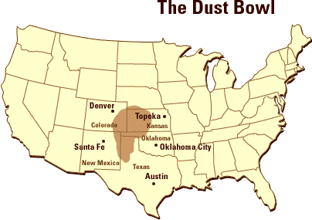
Causes of the Dust Bowl | Effects of the Dust Bowl

What was President Herbert Hoover’s Response to the Great Depression?
“Economic depression cannot be cured by legislative action or executive pronouncement. Economic wounds must be healed by the action of the cells of the economic body – the producers and consumers themselves.” – Herbert Hoover
- Hoover did not believe it was the government’s job to fix the economy or provide financial assistance to citizens
- Opposed gov. handouts, believed it would reduce incentive to work
- Promoted “rugged individualism”:
- Encouraged private philanthropy and “volunteerism”:
- As the Depression dragged on, Hoover called on the government to issue relief checks for the unemployed and approved the construction of the Hoover Damn to put Americans to work. Congress passed the Reconstruction Finance Corps (RFC), which loaned money to save failing businesses. However, these efforts were too little too late. Many citizens had lost faith in President Hoover and grown tired of his inaction.
- Smoot-Hawley Tariff (1830):
  - Hoovervilles:

  - Hoover blankets:

  - Hoover flags

