Significant members of Cabinet | Judiciary Act of 1789
Alexander Hamilton’s Economic Plan | Whiskey Rebellion
Rise of Political Parties (First Party System)
Foreign Problems | Treaties

Proclamation of Neutrality (1793)

Jay’s Treaty (1795)

Pinckney’s Treaty (1795)

Treaty of Greenville (1795)

Farewell Address
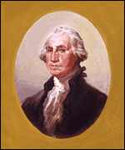
The Presidency of George Washington (1789-1797)

The Presidency of John Adams (1797-1801)

Foreign Problems
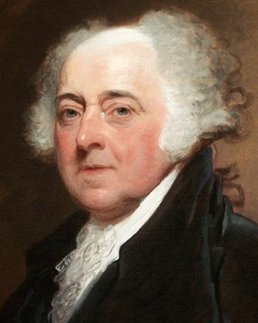
Problems with France

XYZ Affair (1797-98)

Quasi-War with France (1798-1800)

Adams’ Actions in Response to France

Resolution

Laws Passed | Reaction of Democrat-Republicans
Alien and Sedition Acts (1798) | Virginia and Kentucky Resolutions
Election of 1800 | “Midnight Judges”/ “Midnight Appointments”

