Outbreak of WWII
- Define totalitarianism as a system of government.

- In the chart below, list the dictator of each country and the territory that country acquired in the years leading up to WWII.

Country | Dictator | Where did they expand?
Italy
Germany
Japan

- Britain and France responded to the aggression of Germany, Italy, and Japan with a policy of appeasement. Explain.

- What event triggered WWII? When did it occur?

- What nations made up the two major military alliances in WWII?

Allied Powers | Axis Powers

- On the map below, color and label the Allied Power nations and the Axis Powers nations. Color the Allied Power nations Blue and the Axis Power nations Red.
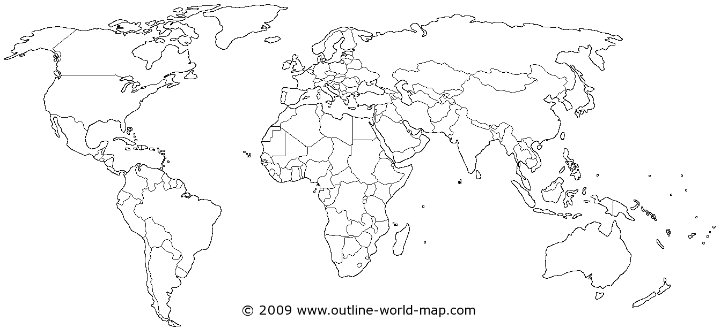

- What nation did Germany invade and conquer in 1940? Which alliance did this weaken?

U.S. On the Sidelines
- What was the United States’ official policy at the beginning of WWII?

- Explain the Neutrality Acts (1935-1937) and their purpose.

- Explain the Lend-Lease Act of 1941. How was this a departure from the Neutrality Acts?

- What event caused the U.S. to officially enter WWII? Include date and detailed explanation.

Fighting WWII
- On the map below, circle and label the two major theaters of WWII. Next to the appropriate circle, list the major combatants in that theater.
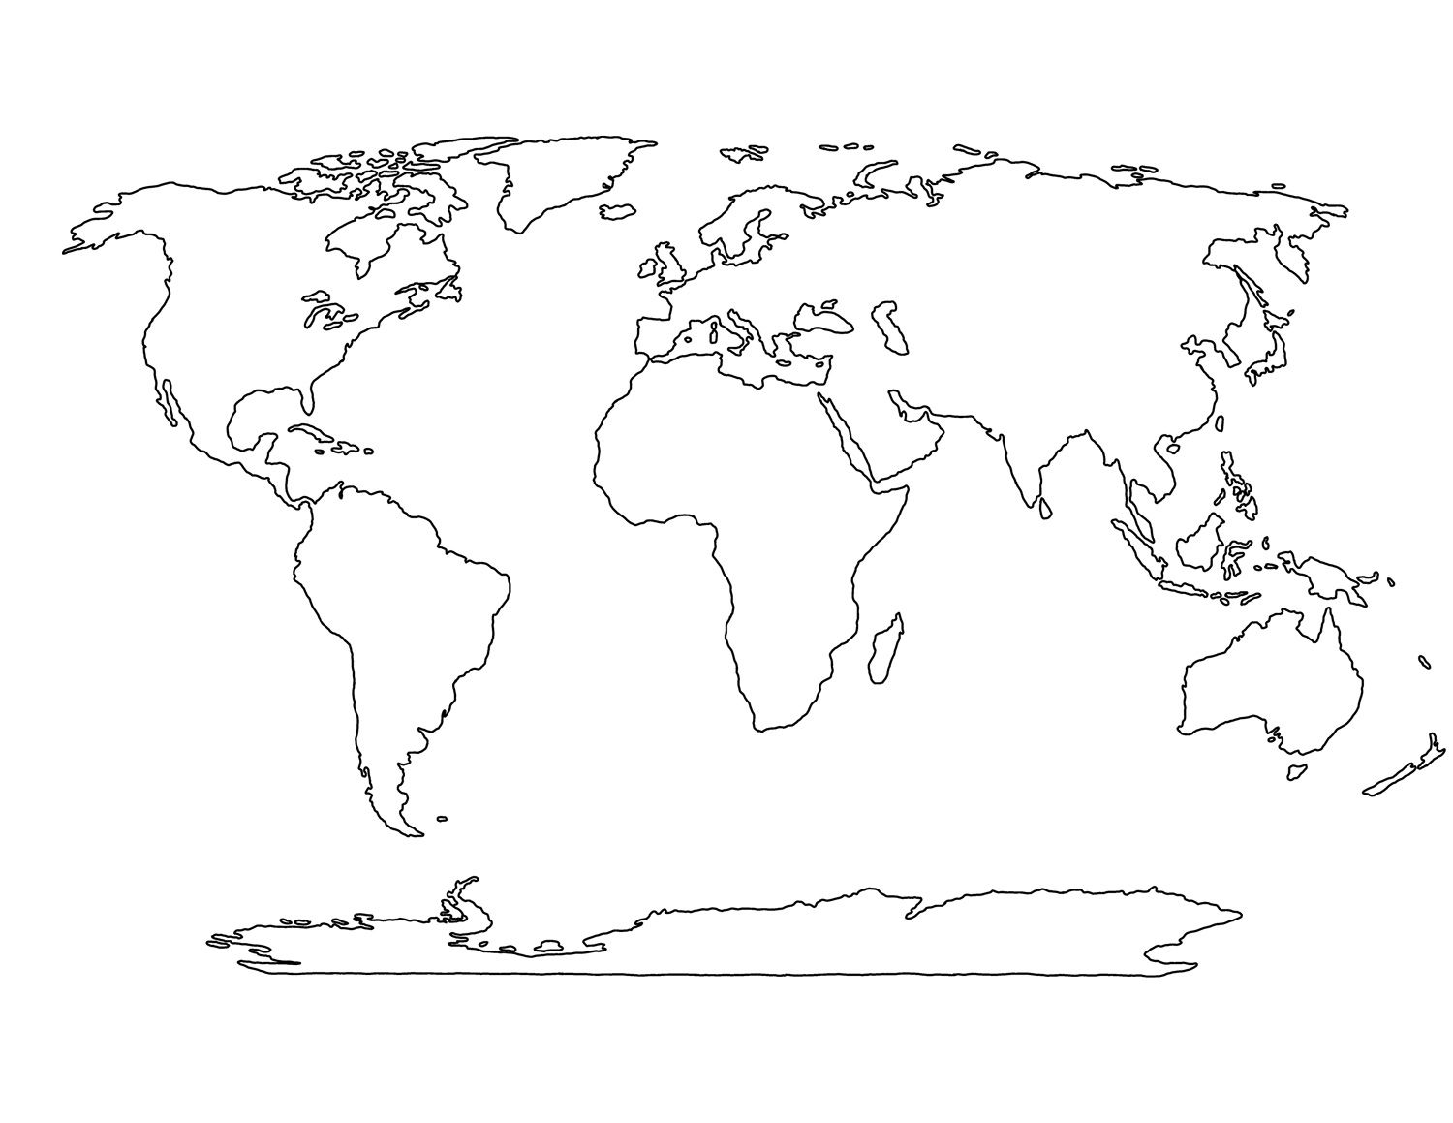

European Theater of WWII
- Complete the chart below with the major battles/events in the European Theater of WWII.
Event | Date | Explanation | Significance
D-Day Invasion
Battle of Berlin
V-E Day

Pacific Theater of WWII
- Complete the chart below with the major battles/events in the Pacific Theater of WWII.
Event | Date | Explanation | Significance
Battle of Midway
Bombing of Hiroshima and Nagasaki
V-J Day

- Which U.S. President made the decision to drop the atomic bombs on Hiroshima and Japan? Explain the U.S. rationale for this decision.

WWII on the Homefront
- Explain the concept of total war.

- Explain how Americans supported the war effort in Europe and the Pacific.
- War Bonds:

- Rationing:

- Scrap Drives:

- Victory Gardens:

Minorities on the Homefront
- What roles did women fill in the U.S. military during WWII?

- What essential jobs did women fill in factories during WWII?

- Why do you think this was necessary?

- Explain the challenges that African-Americans faced on the homefront during WWII?

- Who was A. Philip Randolph and what did he propose African-Americans do in 1941 in response to these challenges?

- How did President Roosevelt respond to A. Philip Randolph’s proposal?

- Why did FDR issue Executive Order 9066 and what did it require?

- What is the significance of the Supreme Court case Korematsu v. U.S.?

Manhattan Project
- What was the Manhattan Project?

- Where was the Manhattan Project’s primary research lab located?

- Why was the Trinity Test on July 16, 1945 so significant?

- What was the ultimate outcome of the Manhattan Project in August 1945?

