Outbreak of WWII
- Define totalitarianism as a system of government.

- Explain the political ideology of fascism. (*fascism is a type of totalitarian gov.)

- In the chart below, list the dictator of each country and the territory that country acquired in the years leading up to WWII.

Country | Dictator | Problem with the Treaty of Versailles? | Where did they expand?
Italy
Germany
Japan

- Britain and France responded to the aggression of Germany, Italy, and Japan with a policy of appeasement. Explain.

- Who attended the Munich Conference in 1938? What agreement was reached at the conference?

- What event triggered WWII? When did it occur?

- What nations made up the two major military alliances in WWII?

Allied Powers | Axis Powers

- On the map below, color and label the Allied Power nations and the Axis Powers nations. Color the Allied Power nations Blue and the Axis Power nations Red.
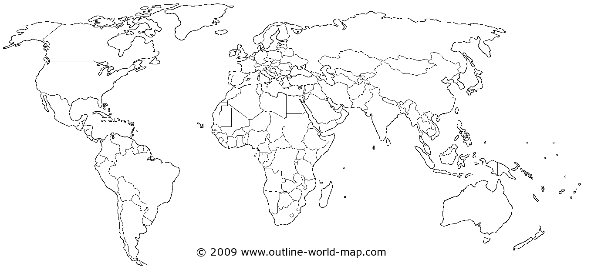

- What nation did Germany invade and conquer in 1940? Which alliance did this weaken?

U.S. On the Sidelines
- What was the United States’ official policy at the beginning of WWII?

- Explain the Neutrality Acts (1935-1937) and their purpose.

- Explain the Lend-Lease Act of 1941. How was this a departure from the Neutrality Acts?

- What event caused the U.S. to officially enter WWII? Include date and detailed explanation.

Fighting WWII
- On the map below, circle and label the two major theaters of WWII. Next to the appropriate circle, list the major combatants in that theater.
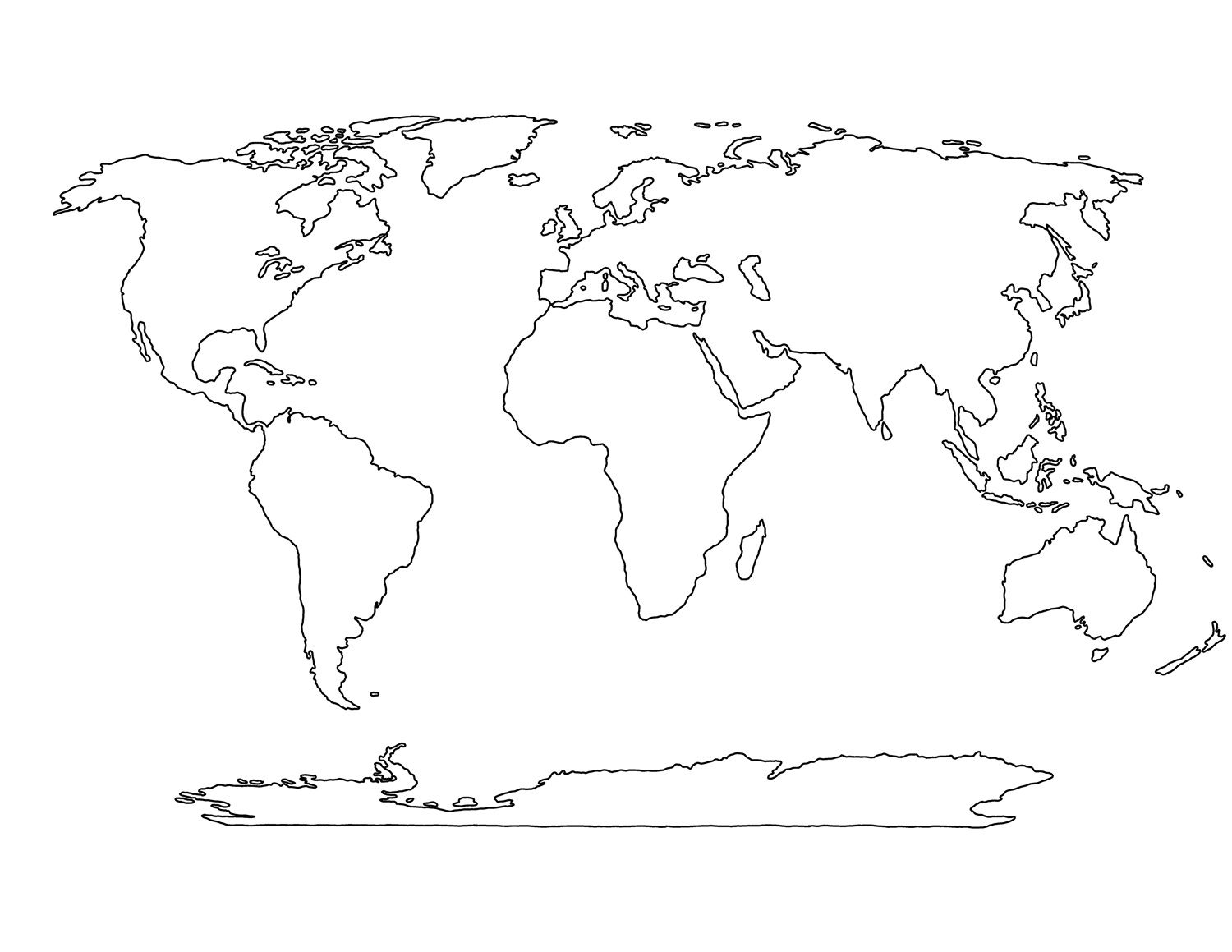

European Theater of WWII
- Complete the chart below with the major battles/events in the European Theater of WWII.
Event | Date | Explanation | Significance
D-Day Invasion
Battle of Berlin
V-E Day

Pacific Theater of WWII
- Complete the chart below with the major battles/events in the Pacific Theater of WWII.
Event | Date | Explanation | Significance
Battle of Midway
Bombing of Hiroshima and Nagasaki
V-J Day

- Which U.S. President made the decision to drop the atomic bombs on Hiroshima and Japan? Explain the U.S. rationale for this decision.

WWII on the Homefront
- Explain the concept of total war.

- Explain how Americans supported the war effort in Europe and the Pacific.
- War Bonds:

- Rationing:

- Scrap Drives:

- Victory Gardens:

Minorities on the Homefront
- What roles did women fill in the U.S. military during WWII?

- What essential jobs did women fill in factories during WWII?

- Why do you think this was necessary?

- Explain the challenges that African-Americans faced on the homefront during WWII?

- Who was A. Philip Randolph and what did he propose African-Americans do in 1941 in response to these challenges?

- How did President Roosevelt respond to A. Philip Randolph’s proposal?

- Why did FDR issue Executive Order 9066 and what did it require?

- What is the significance of the Supreme Court case Korematsu v. U.S.?

Manhattan Project
- What was the Manhattan Project?

- Where was the Manhattan Project’s primary research lab located?

- Why was the Trinity Test on July 16, 1945 so significant?

- What was the ultimate outcome of the Manhattan Project in August 1945?

Major Allied Conferences (use your textbook to explain the location of the conference, who attended each conference, and the purpose/outcome of the conference)
- Casablanca Conference (1943):

- Tehran Conference (1943):

- Yalta Conference (1945):

- Potsdam Conference (1945):

